MES 4th Grade Supply List 2024 - 2025
 | Quantity | Item
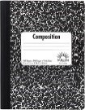 | 4 | Composition books  (speckled, not spiral)
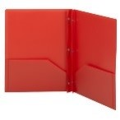 | 4 | 2-pocket plastic folders  (One of each color: Red, Yellow, Green, Blue)
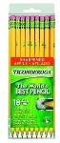 | 36 pack | Pre-sharpened #2 pencils  (Dixon Ticonderoga Preferred)
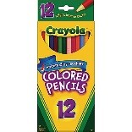 | 1 pack | Colored pencils OR crayons  (Crayola Preferred)
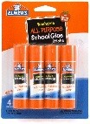 | 4 pack | Glue sticks  (small)
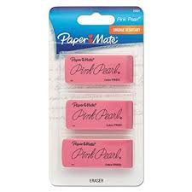 | 1 pack | Erasers (Cap or Large)
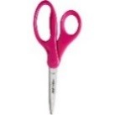 | 1 pair | Pointed child scissors
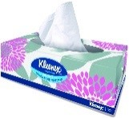 | 3-4 boxes | Kleenex or Puffs tissues
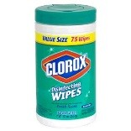 | Boys  1 | Clorox Wipes/Baby Wipes  (75 wet wipes or larger)
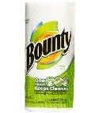 | Girls  1 | Bounty paper towel roll
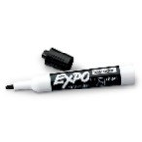 | 6 markers | Black Expo dry erase markers
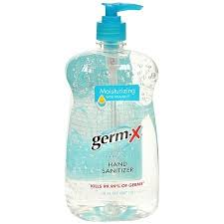 | 1 bottle | Hand sanitizer
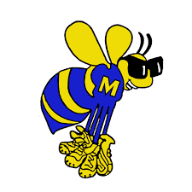 | 1 | MES Agenda  (Available through the school store)
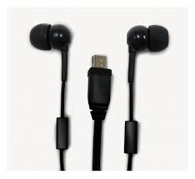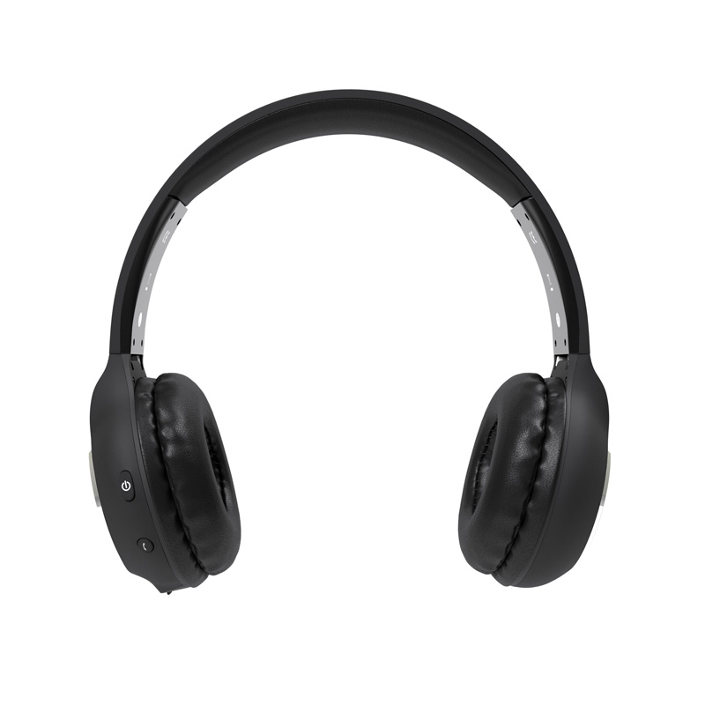 | 1 pair | Earbuds or Headphones
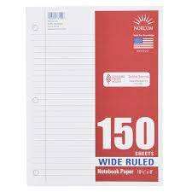 | 1 pack | WIDE-ruled paper

